***Brokr Guide***  
• app/Http/Controllers/Admin: Contains all controllers related to the admin portal.

• resources/views/admin: Contains all views related to the admin portal.  
  
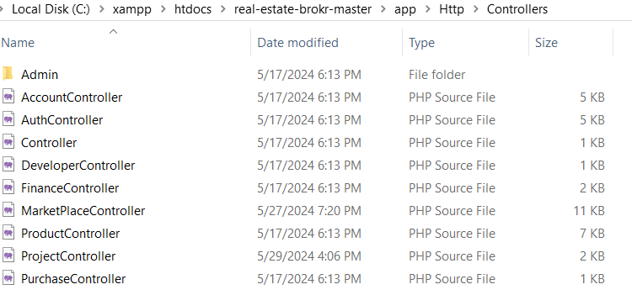  
  
• And same as view ,there is folder in resources>views>admin,which contains all pages of admin dashboard.

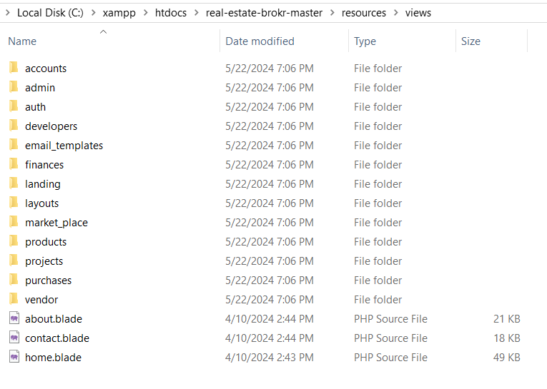  
  
  
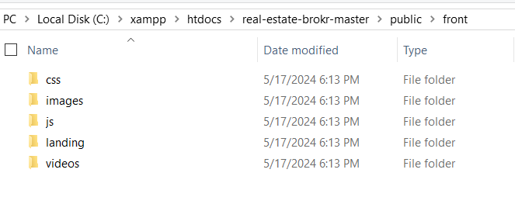  
• All migration files are located in the database directory.

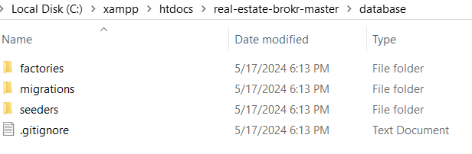

• All models are located in app directory in Models folder.  
  
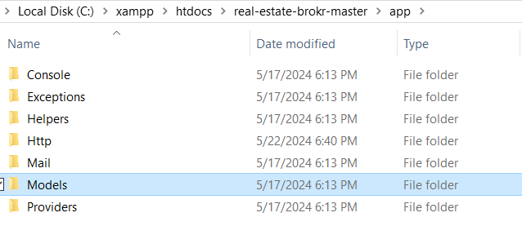  
  
  
  
  
  
• All the routes are defined in the web.php file in routes directory.  
  
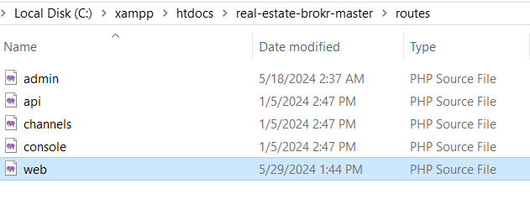

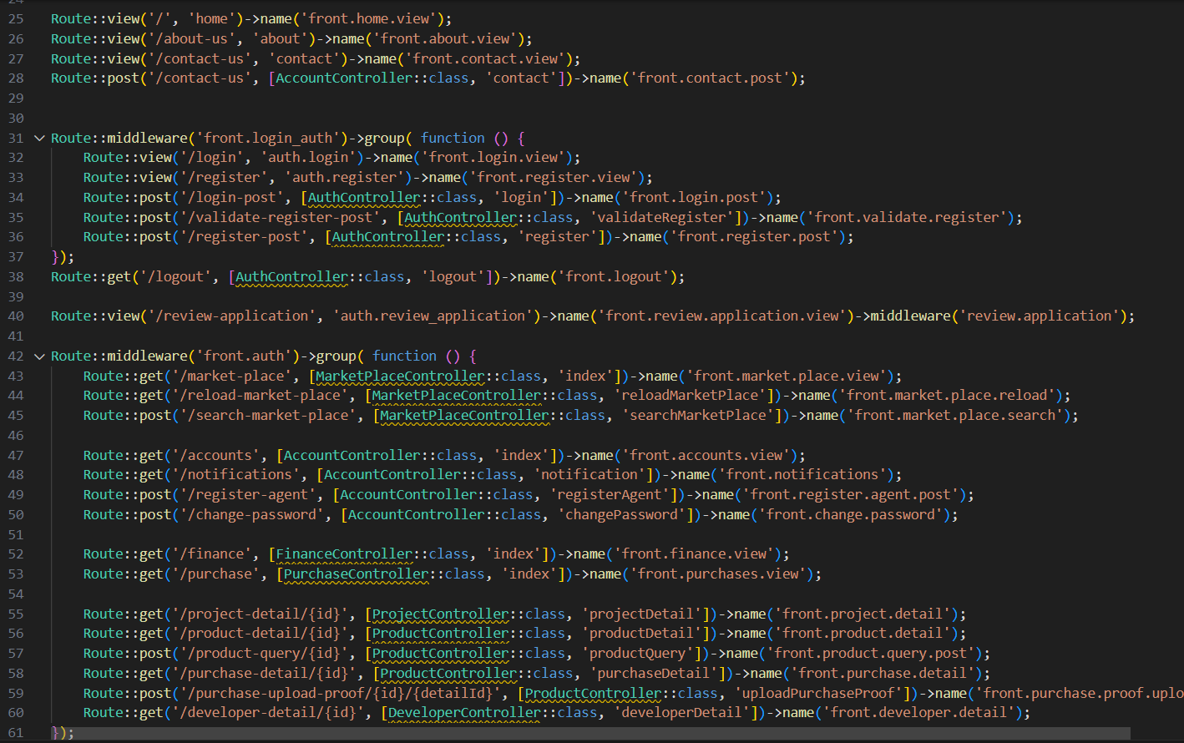

**Proper Directory Structure:**• app/: Contains the core code of the application, including models, controllers, and middleware.  
  
• bootstrap/: Contains the application bootstrap files.  
  
• config/: Contains all of the application’s configuration files.  
  
• database/: Contains database migrations, model factories, and seeds.  
  
• public/: Contains the index.php file, which is the entry point for all requests entering the application, and other assets like images, JavaScript, and CSS.  
  
• resources /: Contains views, raw assets (LESS, SASS, JavaScript), and language files.  
  
• routes/: Contains all of the route definitions for the application.  
  
• storage/: Contains compiled Blade templates, file-based sessions, file caches, and other files generated by the framework.  
  
• tests/: Contains automated tests.  
  
• vendor/: Contains Composer dependencies.